**QUESTION FROM THE ASSIGNMENT**

The data should be joined in Tableau – Assignment left join Leaves and the common key is **Product/Resource reference** from Assignment and **Resource reference** from Leaves.

**SOLUTION**

Kindly notice: **Assignment left join Leaves**

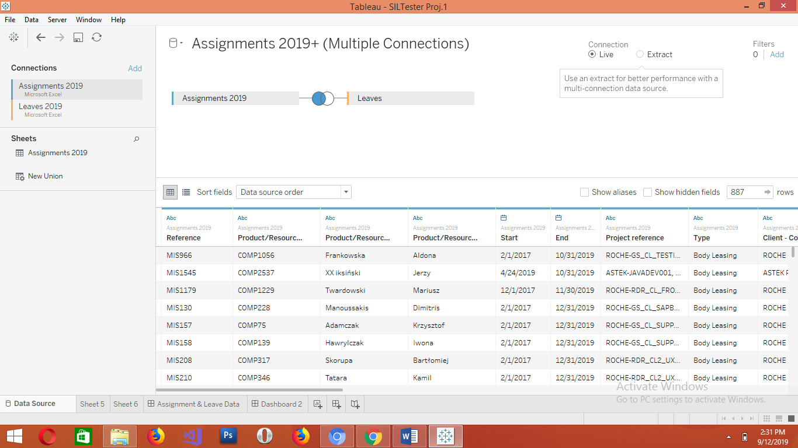

**Result of the total number of employee**

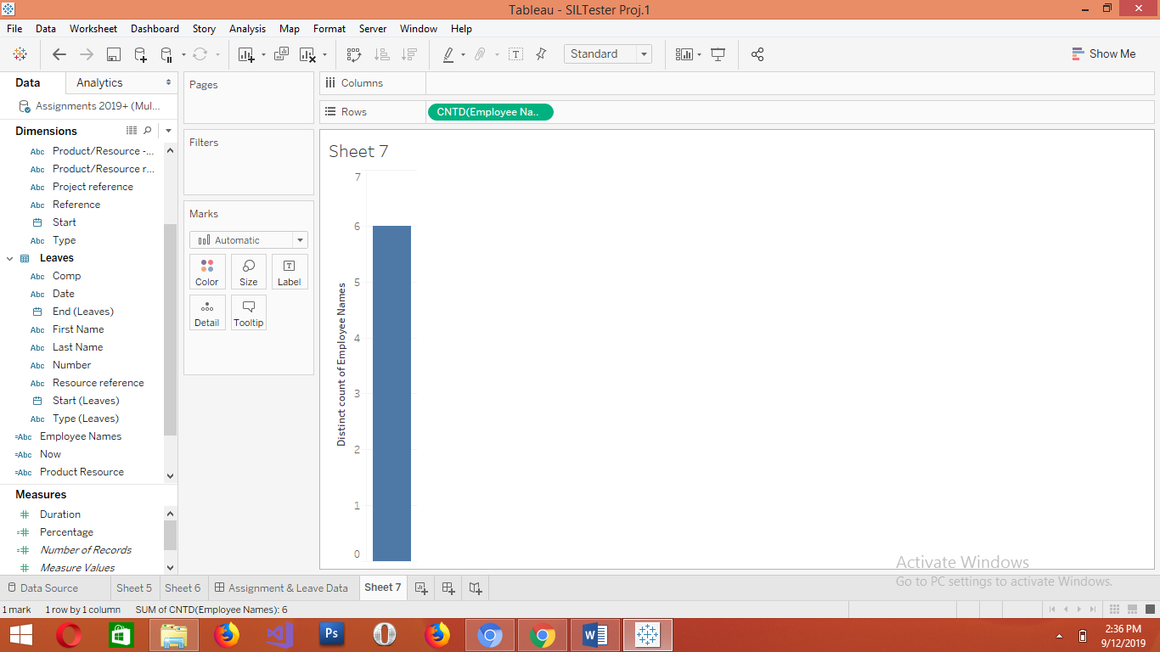

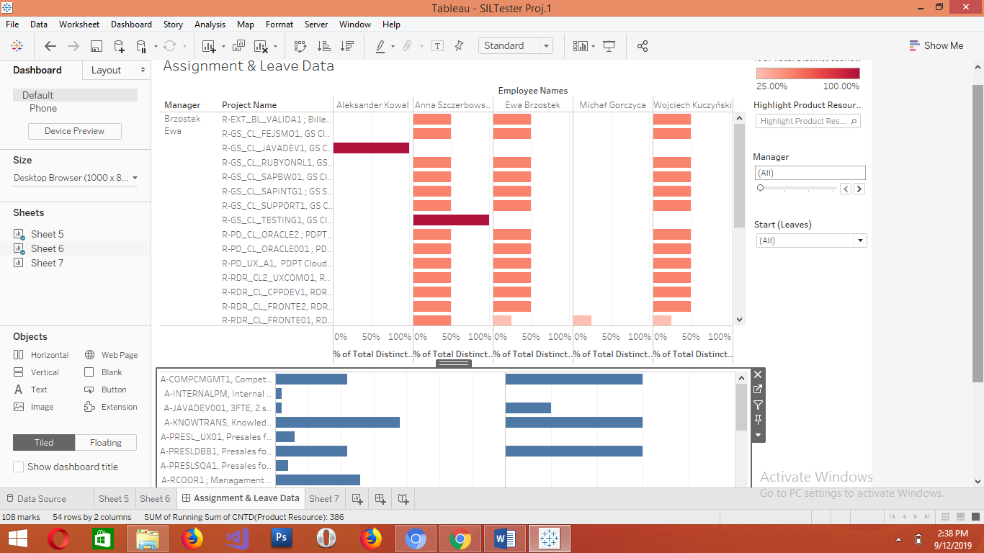

**This is Leave left join Assignment result**

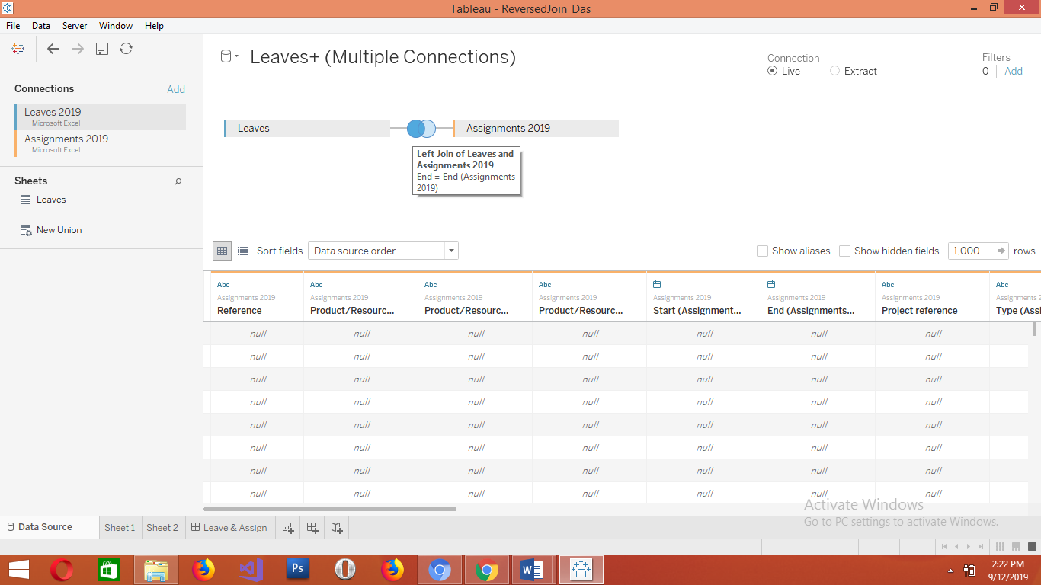

**See the result of the total number of employee**

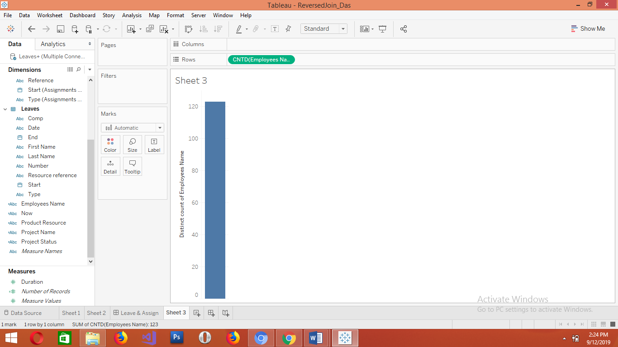

From the image above you can deduce that the total number of distinct employee is 120 but after filters was applied and only the importants data that we need was extracted out, the result below is almost the same with the initial data gotten

